# Linux Folder Structure

/ (root folder):

* Path “/” is the root folder of any Linux system.
* When we run ls -ltr at “/” it will show all the folders and files present in root directory.
* These are the main and important folders of the system.
* To head to root directory from anywhere (cd /).

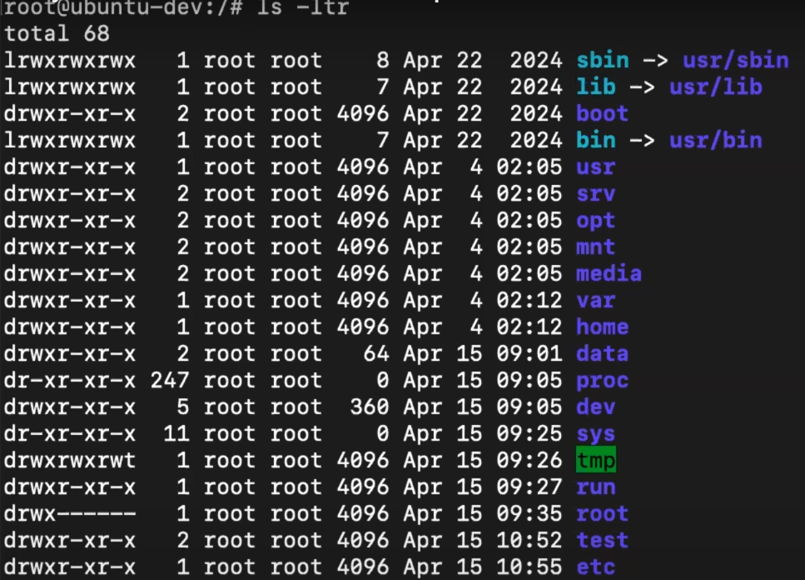

/bin and /sbin:

* Binaries: executable files mean commands.
* Binaries are present in “sbin and bin”.
* Binaries present in ‘sbin’ can be run and executed by system administrator (user with root access) only. These are administrative commands.
* Binaries present in ‘bin’ can be performed by any user. These are not administrative commands.
* Both these folders are originally present in “/usr” but ‘bin and sbin’ are shortcuts for them.

/lib:

* lib folder contains the shared libraries and kernel modules.
* lib is also shortcut for /usr/lib.

/boot:

* boot contains the folders and commands important to boot the system.

/srv (server):

* Configuration files and important info related to webserver is saved in this folder.
* By default, it has nothing.

/opt:

* By default, this also has nothing in it.
* It is used to install 3rd part apps/dependencies.
* It is a practice done by all Linux users in the industry and suggested to do because our other directories (Ex. home directory) may have access to some users too but “opt” is accessible to root user only.
* So, to install anything:
  + go to /opt => cd /opt
  + create a directory in it => mkdir custom-app
  + Go to that directory => cd custom-app
  + And install those dependencies here.

/mnt (mount):

* If there is need to increase the storage of the system, then the mounting of that storage is done here.
* The mounting process is done by Linux administrators via /mnt folder.

/media:

* Store video, audio or image files.
* Not usually used in the industry as there is not much need of that.

/var:

* It contains log files, cache files and lib mean libraries of some third-party apps.
* If we install any server then some of its working paths and files are stored here.
* Ex. www folder is created when we install apache2 or nginx in ubuntu.

/home:

* When we add any user then a directory for that user is created in /home directory and he/she can work in that directory for specific work.
* To use that directory, we need to login as that user.
* Ex. if we create a user named ‘ajinkya’, then a directory named ‘ajinkya’ will be created in /home directory but to access that directory you need to be root user or user ‘ajinkya’ himself.

/data:

* Generally used to store the data or information that needs to be shared with people with administrator access or according to permissions to that directory.

/dev, /proc, /sys and /tmp are useful during scripting work. /tmp can be used to save temporary files that can be deleted later.

/run:

* Store runtime data of the processes.

/etc:

* It has system configuration files.
* Anything related to system or any server, app can be modified using configuration files present here.
* It is like ‘settings’ app in laptop or mobile.